- Storytelling In Photography -

The Smartphone Camera Is Perfect for Storytelling

Don Althaus, M.A.
When the advantages of using a smartphone camera are discussed, the two primary reasons cited are ‘convenience and portability’. And while these are certainly valid and justified, both simplify a reality that has become more evident over the last two or three smartphone-release-cycles, namely that the smartphone camera has become a complete and integrated system capable of producing photographs of the highest quality meeting the vast majority of photographic needs.
Kinda formal, huh?
Here’s another way to look at the situation…
With their advanced cameras, highly developed optics, refined electronics and finely tuned software recent flagship cameras (and to a great extent the second tier cameras in the flagship lines) will give you a complete, totally pocketable photography system that will produce top quality photographs.
No gimbals, no accessory lenses, no accessory lighting, no handles, no cages, no… nothing. Just the phone, a case and you are ready to go. And to clear up any possible misconceptions here we are talking about flagship and second tier flagship phones from the last two or three release cycles.
All of these cameras are fully automatic from the standpoint of white balance, setting ISO, low-light mode, handling the mechanics of focus and exposure, etc., Some of these cameras give you an assortment of focal lengths while others accomplish the same thing by giving you a large standard sensor which affords a crop-to-zoom option.
So what does all of this have to do with storytelling?
Very simply, with the camera doing a lot of the “photo-mechanics-heavy-lifting” based on a screen tap you are free to devote the bulk of your time, effort and concentration to telling the story.
And put another way… because you don’t have to figure out what to do with all the bags and cases of paraphernalia that you think you have to have, you can concentrate on what’s really important... telling the subject’s story.
And yes, it is that simple. You can literally fit a complete smartphone camera kit in your pocket.
(There is much discussion of image quality but there a number of other considerations to deal with before we get to that sticky wicket.)
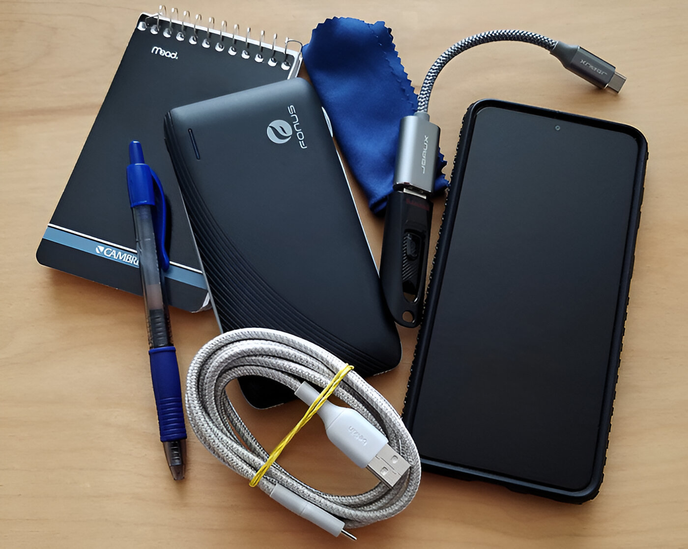Don Althaus
A complete smartphone camera kit - A small notepad and pen, an external battery (if it’s needed), a lens cloth, flash drive and connector to transfer photographs (if needed), and of course, the camera (phone). All of this will fit in your pocket.
With the both incredible flexibility and rock-solid reliability of the technology in today’s smartphone cameras they are quick and easy to use almost regardless of the photographic situation. Bright light, low light, flat light, contrasty light it doesn’t matter. Granted, you can’t just hold the camera up to the scene, push the button and presto-chango have a perfect photograph. You still have to have some idea of what is going on in the scene and figure out what element you want to expose for. But as long as you have an idea what the exposure point should be and tap it on the screen, the camera will figure out the rest.
Because of its size and simplicity, the smartphone camera is astonishingly non-threatening for subjects and gives the possibility of much more natural work. It’s more like a friendly conversation than an interrogation. And it is also significantly less threatening because you don’t need to have the person go through the chrome forest of light stands, camera stands and all that has become associated with photography. It’s more like sitting on a park bench. The work becomes far more personal.
The auto High Dynamic Range feature in smartphone cameras will give you a more natural looking output by balancing lighting to help avoid blown-out highlights overly dark shadows. It will enhance the detail in the structure of the photograph. And it will help establish more natural colors in the photograph. And most modern smartphones have HDR displays so you can see the real-time processed results accurately on the display.
For JPEG output the real time processing in the smartphone camera includes high dynamic range processing, setting the white balance, setting the tonal balance, setting the color balance along with saturation, making exposure control, sharpening, etc.. All of this happens in the veritable blink of an eye given the power of the computer we hold in our hands called the smartphone.
Another advantage of the smartphone camera is the display which becomes the viewfinder… it is the largest viewfinder available aside from the ground glass found on large format film cameras. The image presented on the display is the real-time processed photograph as it would be recorded to the system memory. This is a far better version to show a curious subject than the essentially medium resolution image available on other systems… it’s great for instant feedback.
Other recommending features of the smartphone camera are it is always (or almost always) with you, it has constant connectivity, photographs can be sent anywhere in the world almost instantly and, if really necessary, you can make quick edits right on your phone.
But according to a number of sources, the major consideration when using smartphone cameras is image quality. It is always the 800-pound-gorilla in the room.
The problem is that there is nothing wrong with the quality of the photographs that come from the flagship or second tier cameras over the last two, three or even four release cycles except the belief that there is a problem.
It goes back to the old principle that whether or not there is a problem IN REALITY, if the perception is there, there is a problem.
There are a number of characteristics determining quality when applied to a photograph (several will seem close enough to seem to be repeated but there are subtle differences that make them distinct from each other and they are presented in no particular order):
- Sharpness: The level of detail the photograph conveys capturing fine textures, edges and intricate features clearly.
- Noise: Random variations in image quality appearing as grain in film based photography or pixel level variations in digital photography.
- Dynamic range: The span of light levels a camera cam capture in f-stops, EV or zones.
- Spatial resolution: The level of detail a photograph can reproduce depending on the pixel count and optical quality
- Contrast resolution: (bit depth) The range of gray levels a camera can capture per pixel defining the brightness variations in the photograph.
- Color fidelity: The faithful representation of colors in the photograph.
- Artifact creation: The creation of unwanted and unintended alterations or distortions in the photograph during capture, processing or transmission.
- White balance: Adjusting colors to appear natural and accurate compensating for the color temperature of the light source.
- Brightness: (accurate reproduction) The overall lightness or darkness of a photograph adjusted to improve visibility and contrast.
- Focus: The sharpness and clarity of the photograph.
- Tonal reproduction The range and accuracy with which the camera reproduces tones (shades of gray) from deep shadow to highlights.
- Vignetting: Diminishing brightness and or saturation at the edges of a photograph.
- Lateral chromatic aberration – LCA – or fringing: Lens aberration causing colors to focus at different distances from the photograph center, most visible at corners or edges.
While still in the near-photo quality stage photographs produced by smartphone cameras had issues with several of the characteristics listed above – sharpness, dynamic range, noise and fringing were all suspect. Arguably smartphone photography crossed that invisible line between near-photo quality and photo quality quite some time ago but we continue to hear that the work is deficient.
More often than not this is simply made as a blanket statement with no specifics. It is usually something along the lines of “well, they’re just not as good as a real camera. I mean they’re OK for Instagram but not for serious work.” First, we have never defined “serious work” by the equipment used to make it. And second, the smartphone camera is a “real camera”.
When criticisms are more specific they usually fall in two areas, one of which is included in the list – dynamic range – and the second – surprisingly not included to the list – is low-light response. Out of all those listed characteristics we’re down to one...
The question is how do we measure that elusive photographic essence?
There are some approaches that involve elaborate measurements and even more elaborate mathematics. In reality that’s stuff most of us mere mortals would have no hope of understanding even if we memorized the entire book “Dynamic Range for Dummies”. And the results can be just as confusing as the process.
In real life terms, dynamic range is the ability of the camera to record texture and details through a range of light levels ranging from the darkest to the brightest. And the best way to evaluate that is with the photograph our cameras produce... well lit photographs with a full range of tones in scenes with plenty of detail in the shadows and textures in the highlights.
A full range of tones are revealed in this full-sun exposure. You will note that texture and detail are evident in the shadow areas including the tire tread and the grass in the shadow area in front of the car while there is sufficient detail in the chrome wheels and in the white car behind the subject vehicle. Detail in the grill work is astonishingly clear as are the variations in the paint cause by reflections of the surroundings.
Taken with iPhone 15 Pro Max Don Althaus
It would certainly appear that dynamic range is not a problem – texture and detail in areas from dark to light. And let’s not forget that dynamic range is not a function of the scene but rather of the camera being used to photograph that scene. That camera has that same dynamic range capacity regardless of the scene and that capacity is not variable.
The next area of concern is low light response.
In this low-light photograph details and textures even into the darkest areas are clearly visible and well defined. Highlights are well defined with detail and texture clearly visible. Variations of tone in the street area are well defined and the gradation of the night sky is continuous without any obvious banding. And while there is a minor degree of noise, it is not noticeable unless you are looking for it and, as such, is certainly not objectionable.
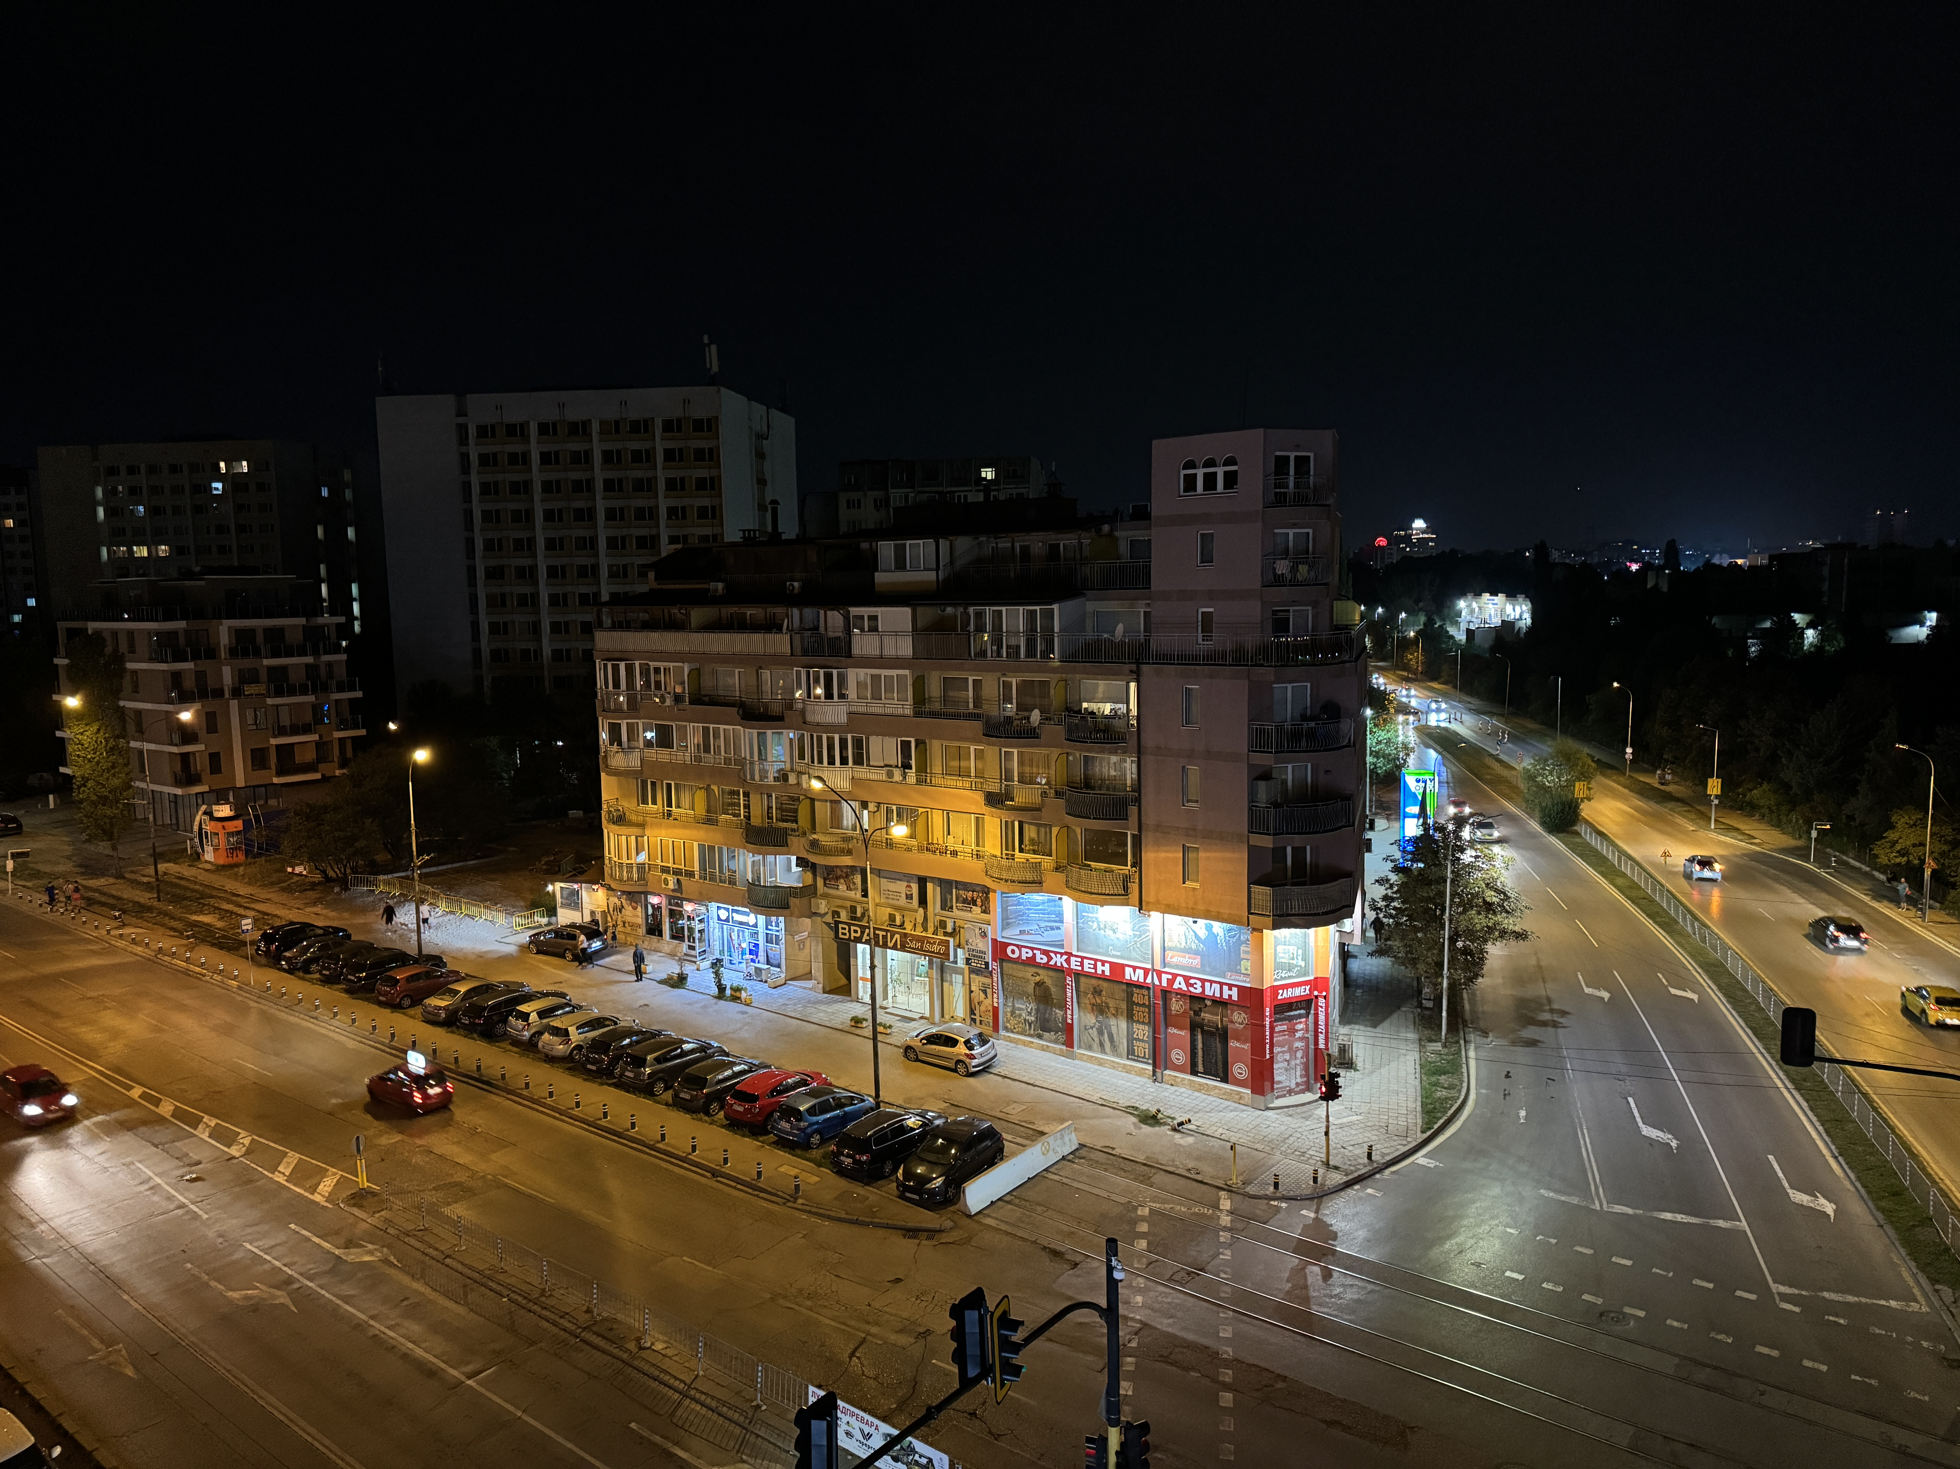Taken with iPhone 15 Pro Max GSMArena
Again, this response is a function of the camera being used to photograph the scene.
These samples appear to be fairly representative of the quality available in the flagship and the second tier smartphone cameras.
Noise is another area that draws a lot of attention but the problem here is that noise in a photograph is more often that not “operator error”. Deliberate underexposure, soft focusing, setting an unrealistically high ISO and progressive defocusing are all things that will exacerbate noise in a photograph. But the biggest source of noise is saving a photograph to any of the camera raw formats. It doesn’t make any difference which format, they are all harbingers of noise. JPEGs not nearly so much, if they are done correctly, of course.
When a photograph is taken, the data from the sensor – which is actually analog, by the way – is routed to an analog-to-digital processor. If you are saving the photograph as a JPEG, the data is sent to the demosaicing algorithms and then to a noise reduction algorithm. The noise is removed before the data becomes an integrated file. The data is then given some initial processing – white balance and gamma correction and then moves on to the image processing algorithms which apply all of the other components reported in the metadata including sharpness, color saturation, color correction, etc. From there the data goes to the JPEG algorithm and it reported out as a finished JPEG photograph.. When it is reported out it is already denoised.
If you are saving the photograph as a camera raw the data travels from the sensor to the analog-to-digital converter which reports it out to the demosaicing algorithms. Here is where the change comes… The demosaiced data is sent to the initial processing units where it is white balanced and gamma corrected and then, along with the metadata, reported out. All of the noise is reported out as an integral part of the photograph’s structure. Because of its structural nature it can’t be removed per se. Most post processing noise reduction systems simply isolate it and cover it up using interpolation.
There are two things about this whole noisy discussion – first, it applies to all digital cameras not just the ones in smartphones and second, unless a reviewer is very specific, comments about noise should be taken with a very large grain of salt.
Authors Note: I would like to wrap this section with an observation… we continue to hear and read a number of complaints about the quality of smartphone cameras but we NEVER see examples of what the complaint alleges nor do we see comparisons illuminating the complaint. Many of these complaints are rehashing things from years ago that continue to be promulgated for some reason.
Because of the exceptionally high image quality of smartphone cameras and a continuing failure to provide solid examples to back up complaints, they must be viewed with increasing skepticism. In the end, the current smartphone camera is a competent, high quality photographic device that is well suited to a variety of uses including storytelling.
So if noise is as much a user problem as anything else how do we control it?
The first step is to select the lowest ISO appropriate for a given scene. We are very fortunate in that the smartphone camera will automatically select the lowest and most appropriate ISO for the scene. Bear in mind that the lowest ISO is not always the most appropriate so this is where the idea of “lowest and best” comes in.
Bear in mind also that as the ISO drops you may lose a bit of dynamic range but generally when the phone is making the assessment the algorithms are evaluating the scene to give the best overall ISO level. In the three photographs presented here the ISO for the camera kit was set at 200, the ISO for the car was set at 80 and the ISO for the night photograph was set at 800.
The next consideration for the lowest possible noise level in a photograph is making sure there is an over all level of sharpness. The sharper and more in focus the elements the less noise there is. Cloud-like flowing water, soft-focused backgrounds and similar invite noise, especially if the areas are approaching softer middle tones.
The third consideration is using the in-camera noise reduction system. There are all kinds of arguments possible against this but the fact-of-the-matter is the in-camera system is computationally the best defense against noise and the first line assurance of data integrity when the photograph is reported out.
Here is the reality as some may argue they prefer to shoot in raw over JPEG for the expanded post-processing choices (regardless of the camera you are using) – you will simply have to accept the increased noise levels as part and parcel of the raw file package. Period.
The final consideration here is to optimize for as full range exposure from shadows to highlights.
And finally, avoid at all costs the temptation to examine you photographs at anything more than a 100% zoom level.
Having said all of this, there are some distinct challenges using a smartphone camera.
If you do a lot of studio work you can’t use your regular flash setup. Because of the way the cameras report the data from the sensor, a regular flash won’t work. The alternative is to use continuously burning LED panels.
The handling of a smartphone camera is different from the 35mm-style dSLR camera or the bridge-style mirrorless camera so it takes some patient practice to get to the point where picking it up and using it is “second nature”. This leads to a similar point – namely that there is a distinct learning curve for the smartphone camera -
- in some cases, the learning curve is the same as any other camera... reading the light, getting the composition set, etc. so the learning curve here is simply applying previous knowledge to a new situation.
- in some cases the learning curve is simply adapting... to the larger viewfinder, doing basic editing on the phone if necessary, being interrupted by a phone call, etc.
- and in some cases it is unlearning what we knew and learning a whole new approach to things like determining exposure, adapting to a fixed aperture (but it seems this may be changing in the few release cycles), etc.
And finally, there is a perception of a lack of professionalism in using a smartphone camera but that too is changing.
The conclusion here is really very simple – there is no perfect camera but given the current state of smartphone camera development over the past two, three or even four release cycles, the top tier flagship and second tier flagship camera is a more than competent photographic device that will meet the needs in the vast number of situations.
This is certainly true for storytelling… it is the almost perfect camera.

